**Etain’s final submission for the ‘big project’ as part of module 52957 - DATA-REPRESENTATION.**

**Lecturer: Andrew Beatty**

**Student: Etain Upton G00318876**

**I chose to complete Option (A) for this assessment – a Web Application based on;**

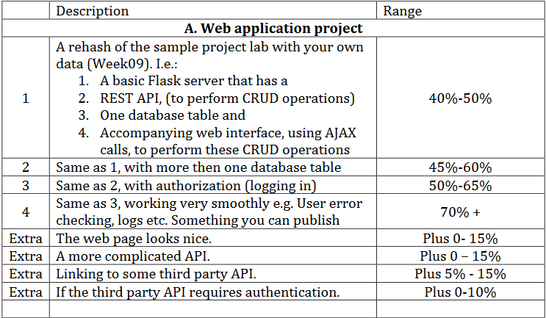

I found this module challenging. I successfully managed to complete Lab 01 but struggled with Lab 02 onwards.

I ran into issues following the *Lab 05.2 Flask* instructions;

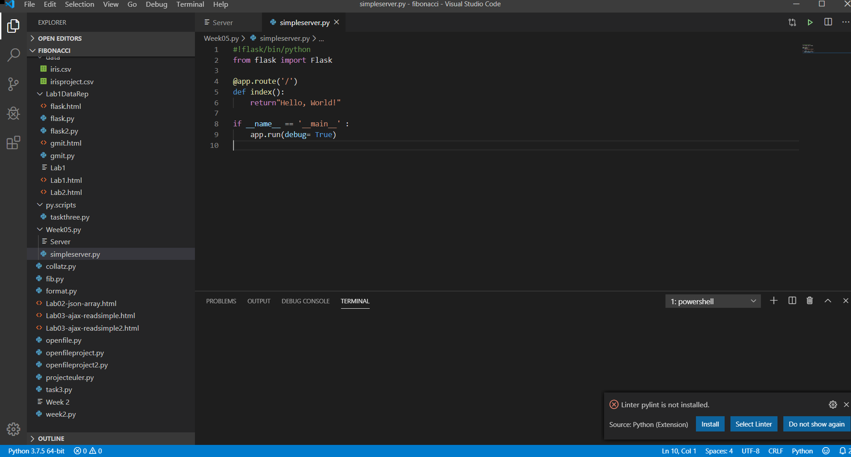

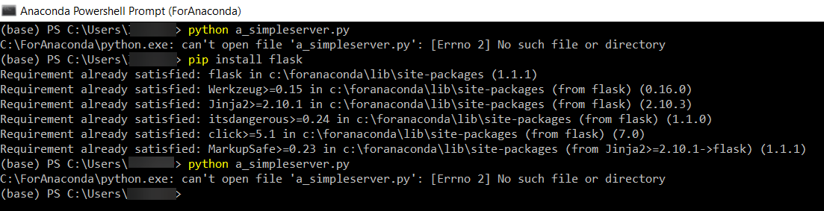

As shown above, I continued to get the error ‘C:\ForAnaconda\python.exe: can't open file 'a_simpleserver.py': [Errno 2] No such file or directory’.

I struggled to progress past this.

I have included my code below for review.